Who am I?
Listening, Attention and Understanding    - Understand how to listen carefully.  - Participate in small group class discussions.  - Listen to familiar stories with increasing attention and recall.  - Ask and answer simple questions.  Speaking  - Speak in full, short, simple sentences.  - Follow simple two-step instructions.  - Join in with repeated refrains, nursery rhymes and familiar songs.  - Learn and use newly taught vocabulary in context.  - Share and talk about own experiences and family celebrations | Understanding the world    Through exploration and experiences, your child will develop a sense of the world around them. They will:  - Be able to name and describe people who are familiar to them.  - Explore similarities and differences of ourselves and our families.  - Explore and understand the effect of the changing seasons in the natural world around them.  - Learn about different cultural celebrations, including Diwali and Christmas. The children will have the opportunity to explore artefacts relating to these festivals.
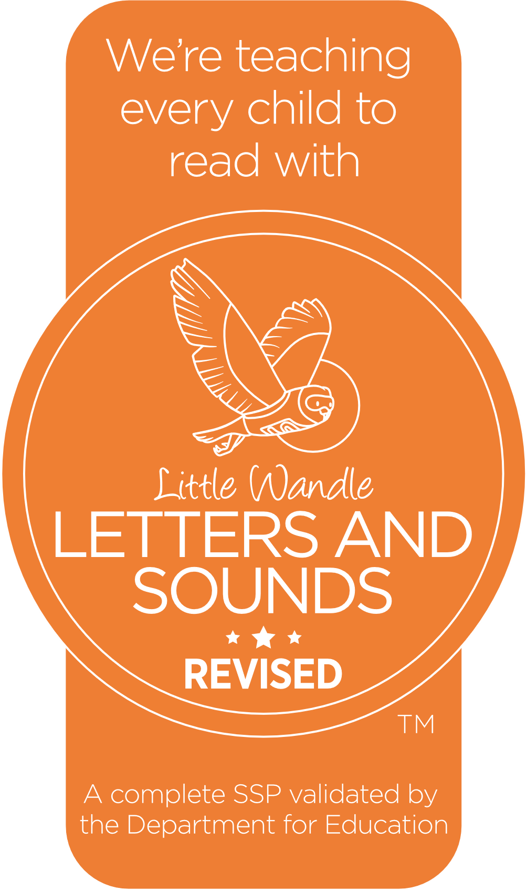  Phonics  The children will follow the Little Wandle Phonics scheme. They will be taught the following phonemes and tricky words:  - s a t p i n m d g o c k ck e u r h b f l.  - ff ll ss j v w x y z zz qu ch sh th ng nk.  - I is the put pull full as and has his her go no to into she out has we me be.  The children will also be taught to segment and blend two and three letter words during weekly Phonic and Reading sessions. | Expressive Arts and Design    Through practical experiences, the children will have the opportunity to:  - Explore different materials and make marks with a variety of media.  - Explore colour and how colours can be changed.  - Create drawings of their families and self-portraits of themselves.  - Experience and react to different styles of music.  - Recite poems and sing a variety of songs including nursery rhymes.  - To explore and use different musical instruments, learning how to keep a pulse.
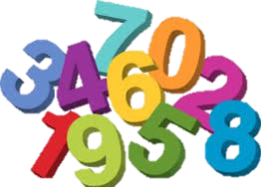  Mathematics  - Subitise (instantly recognise how many objects there are without needing to count) quantities up to 4 and identify sub-groups within larger groups (for example, 1 and 2 make 3 altogether)  - To understand the number system to 5 and use this to count amounts with 1:1 correspondence.  - To explore composition using collection of objects and begin to understand the terms of ‘parts’ and ‘wholes’  - To compare sets of objects using ‘more than,’ ‘fewer than’ and ‘equal’.  - In addition, the children will also explore 2D shapes, spatial vocabulary, repeating patterns and mass and capacity. | Personal, Social and Emotional Development  We follow the Cambridgeshire PSHE scheme of work. The children will:  - Learn names and develop relationships with adults and peers in their class.    - Learn to ask an adult for help.  - Begin to learn to share and turn take with others.  - Share the class rules and routines.  - Begin to identify, name and regulate their emotions.

Physical Development
All children will partake in daily activities to help develop their fine motor skills to aid the preparation needed for writing.
Your child will have weekly PE sessions to help develop their gross motor skills.
Enhancements/Wow moments/Hooks
We will be going on a tour around our school and its grounds to help us become familiar with our new setting.
We will celebrate different cultural celebrations and festivals that reflect the children in our cohort.
Please speak to a member of the Reception team if you would like to visit us to talk about your family’s special celebrations.


